Tuning Process

One of the painful things about the training deep nets is the number of hyper parameters we have to deal with. These include learning rate alpha, momentum term beta, or if using adam, then beta1 and beta2 and epsilon. Another are number of layers, number of hidden unit for the different layers and learning rate decay. Last but not the least the mini batch size.

The learning rate is the most important hyper parameter to tune. Next comes the momentum term, mini batch size and number of hidden units. Next in importance comes number of layers and learning rate decay. When using Adam algorithm we pretty much never tune beta1, beta2 and epsilon.

When tuning a set of hyper parameters how do we select a set of values to explore?

In earlier days of ML, we would sample the points of the hyper parameter and systematically explore the values. Try out all the values and then pick whichever performs best. This practice was okay when the number of hyper parameters was relatively small. For deep learning we choose the points at random, because we do not know which hyper parameters are going to be the most important for our problem.

Sampling at random ensures that you are more richly exploring a set of values for the most important hyper parameters whichever they turn out to be.

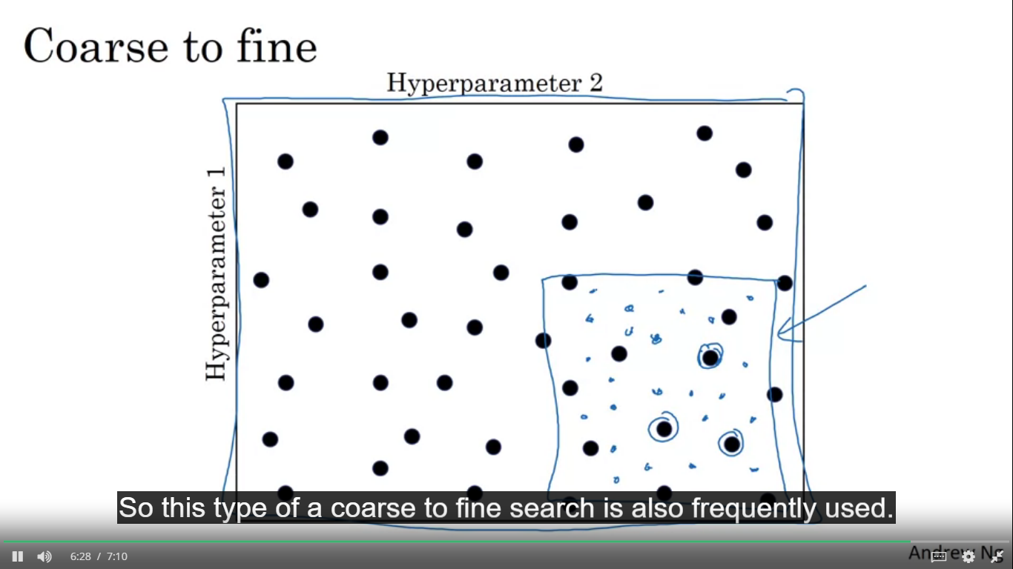

Another common practice is to use a coarse to fine sampling scheme. In this you zoom in to smaller region which has hyper parameters working best and then sample more densely within this space.

**Using an Appropriate scale to pick hyper parameters**

Sampling at random doesn’t mean sampling uniformly at random over the range of valid values. Instead it is important to pick the scale on which to explore the hyper parameters.

Let’s say alpha(learning rate ) has values between 0.0001 and 1, so if we sample uniformly at random on this number line , about 90% of the values we sample would be between 0.1 and 1. So we are using 90% of resources on 0.1-1 and 10% resources on 0.0001-0.1. so instead we can search for hyper parameters on a log scale. You get the type from the fig and you sample uniformly at random on this type of logarithmic scale.

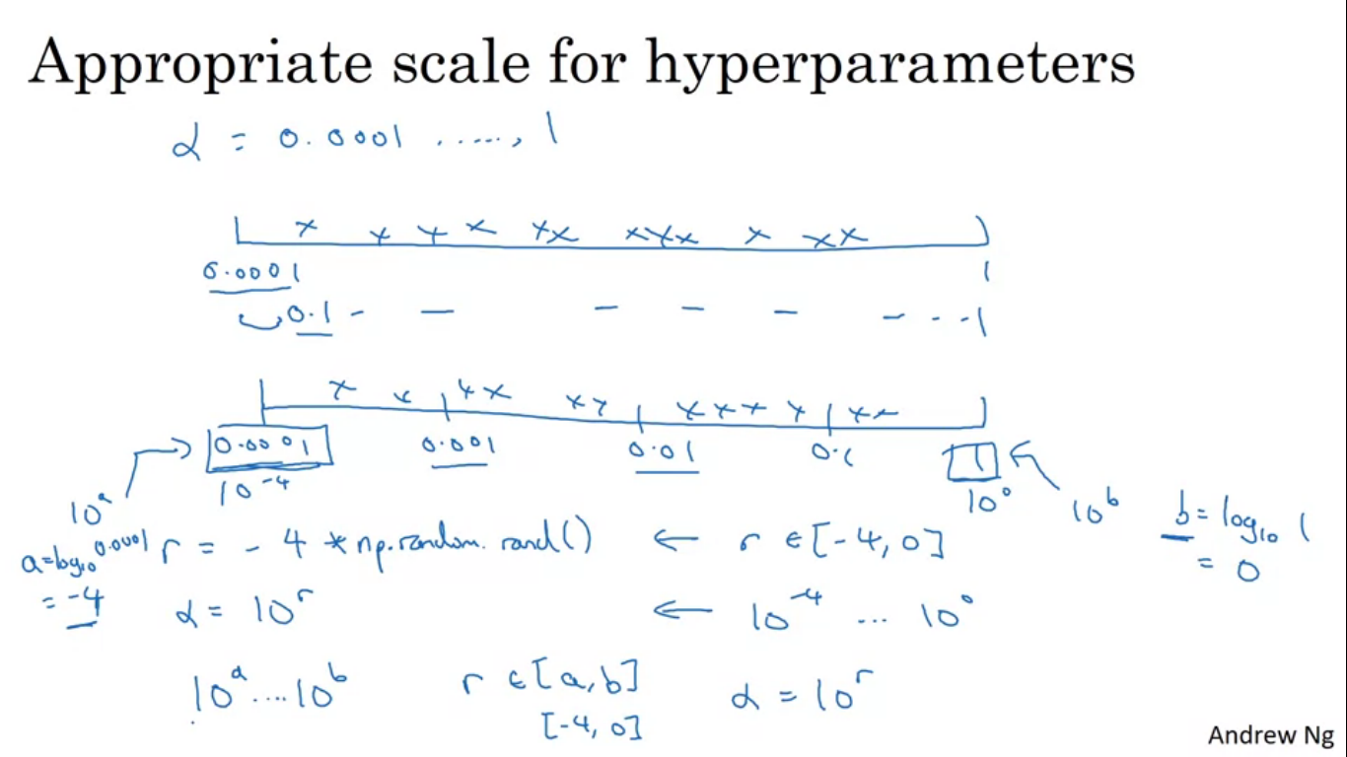

In python done using: -

R = -4*np.random.rand()

Alpha = 10^-R

R will be random number between -4 to 0 and alpha would be 10^-4 to 1

Hyper parameter beta used for computing exponentially weighted average. Using 0.9 is like averaging over last 10 values whereas using 0.999 is taking the average of last 1000 values. So to sample on 0.9-0.999, it doesn’t make sense to sample them on a linear scale. We use logarithmic scale.

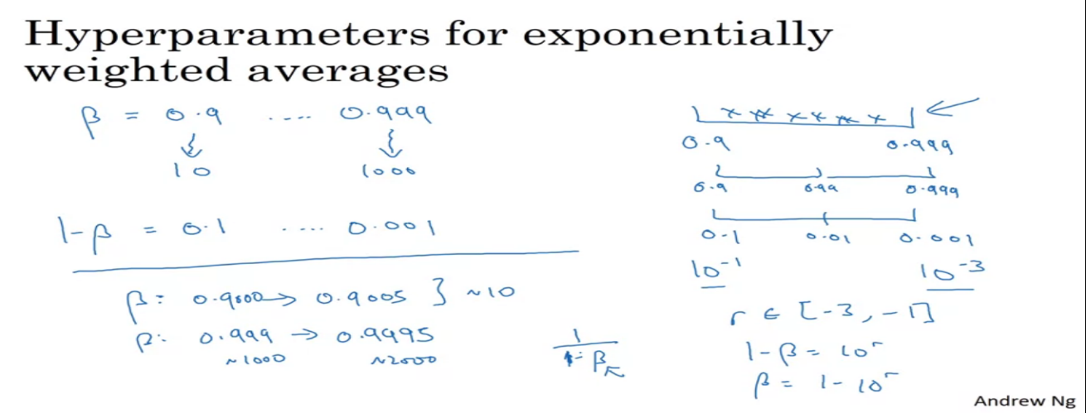

Why linear scale is not preferred ?

When beta is very close to 1, the sensitivity of the results we get changes even with very small changes to beta. So if beta goes from 0.9-0.9005 there is hardly any change but if the value goes from 0.999-0.9995 this will have an impact on the algorithm since in this the exponential average will change from last 1000 examples to last 2000 examples.

The formula 1/1-beta is very sensitive to small changes in beta when beta is close to 1.

Organizing the hyper parameter search process

Intuitions and hyper parameters do get stale, so we should retest and re-evaluate our hyper parameters.

**Two ways of searching hyper parameter**

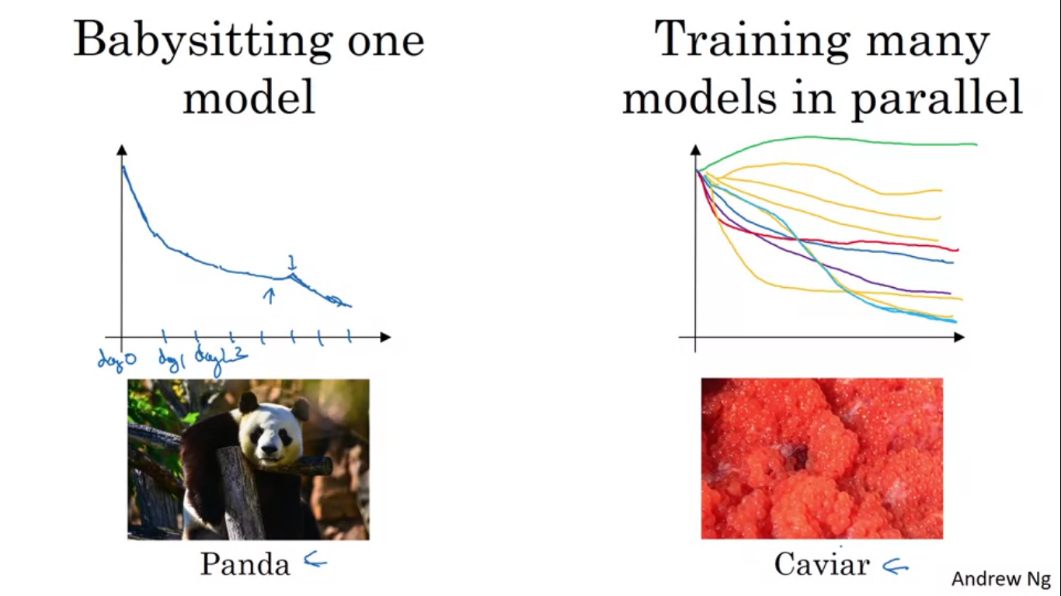

Babysit one model – huge dataset but not a lot of computational resources so we can afford to train very small models at a time. Every day we look at it and try nudging up and down our parameters.

The other approach is if we train many models in parallel, this way we can try many hyper parameter settings and maybe pick the one which works best.

**Batch Normalization**

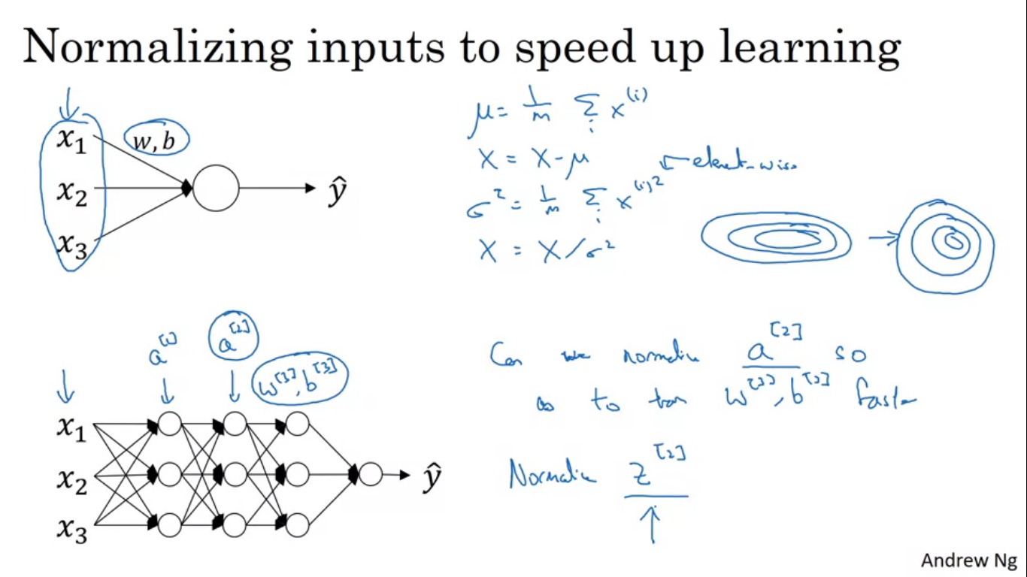

While training a model, such as logistic regression, normalizing the features can speed up learning. So we compute the means and subtract means from the training sets, compute the variances and then normalise the dataset according to the variances. It transforms the contours of our learning from something very elongated to something very regular shaped and easier for gradient descent to optimize.

So this is how we can normalize input features x, but what about deeper nets. So if we want to find w[3],b[3] we would want the features coming out of a[2] to be normalised. But the question is can it be done? Technically we will normalize the values of not a[2] but Z[2].

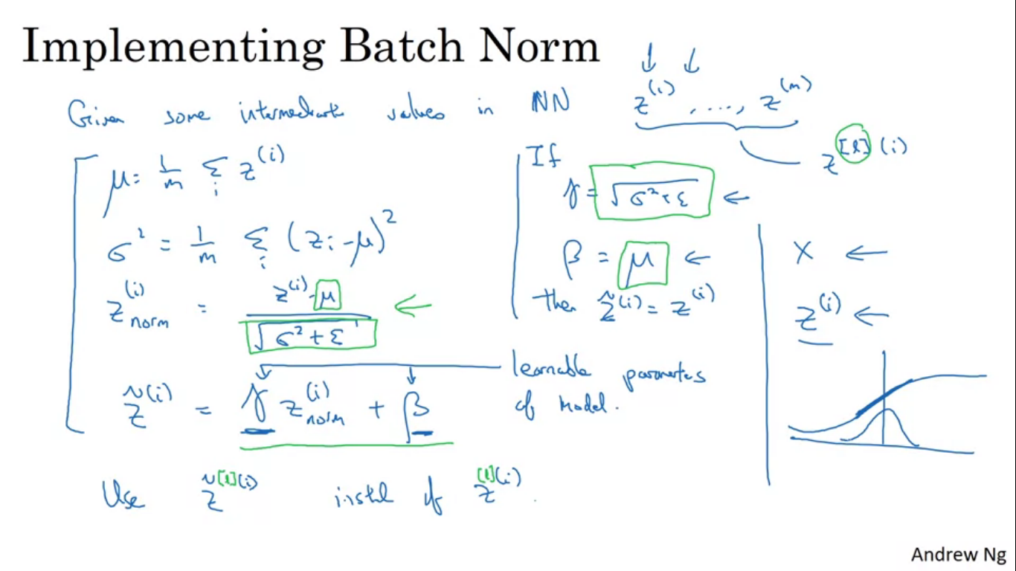

We take the values Z and normalise them to have mean 0 and variance 1. But we don’t want hidden units to always have mean 0 and variance 1. So we calculate

Z~ = gamma*Z(i)norm + beta,

where gamma and beta are learnable parameters which are updated just as we would update the weights of the NN.

If gamma = sqrt(sigma^2 + epsilon) and beta = mean,

Then Z~(i)norm = Z(i).

By changing the values of gamma and beta it allows us to have other vales of means and variances as well. So now we use Z~(i) instead of Z(i) for the later computations in our neural network.

Batch norm to a single hidden layer

**Batch norm for training a complete network**

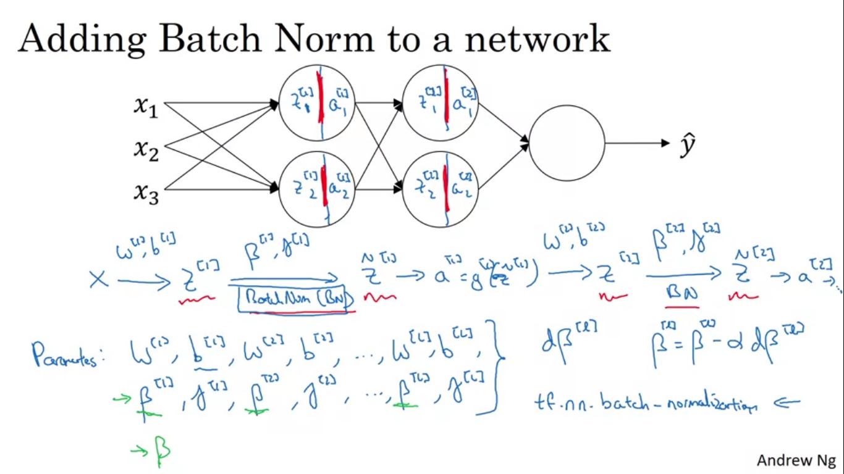

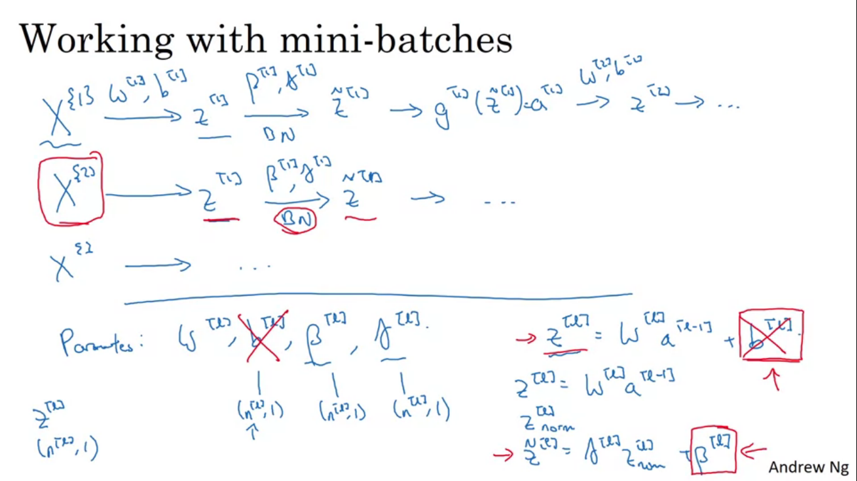

Instead of using Z we use the batch normalised value Z~ in the NN.

So parameters are w[1],b[1],w[2],b[2],....w[l],b[l] and also added to this NN are beta[1],gamma[1],beta[2],gamma[2],....beta[l],gamma[l].

The beta here is different from the one we used to calculate momentum over computing exponentially weighted averages.

Using batch norm with the mini batches of the training set

We normalise Z with just the data in the current mini batch and not the whole training set.

Z[l] in mini batch is found out and then normalised by finding out the mean and subtracting it so the value b[l] is just going to get subtracted out. Any constant you add gets cancelled out by the mean subtraction step.

The dimensions of beta and gamma are (nl, 1).

**Why Does Batch Norm work?**

By normalizing all take up the same input feature X on a similar range of values that can speed up the learning. Batch norm makes the weights deeper in the network more robust to changes to weights in the earlier layers of NN.

Example using the logistic regression for classification of cats, but let’s say we have trained your data sets on all images of black cats. So if we now try to apply this network to the data with coloured cats, then our classifier might not do very well.

The idea of data distribution changing goes by the name of covariate shift. Main idea is you’ve learned some X->Y mapping, if the distribution changes , then we might need to re-train our learning algorithm. This is true even if the ground truth function remains unchanged. In this example the ground true function is, is this a picture of a cat or not. If the ground true function shifts as well, then the need to retrain becomes even more acute.

**Why covariate shift is problem with NN?**

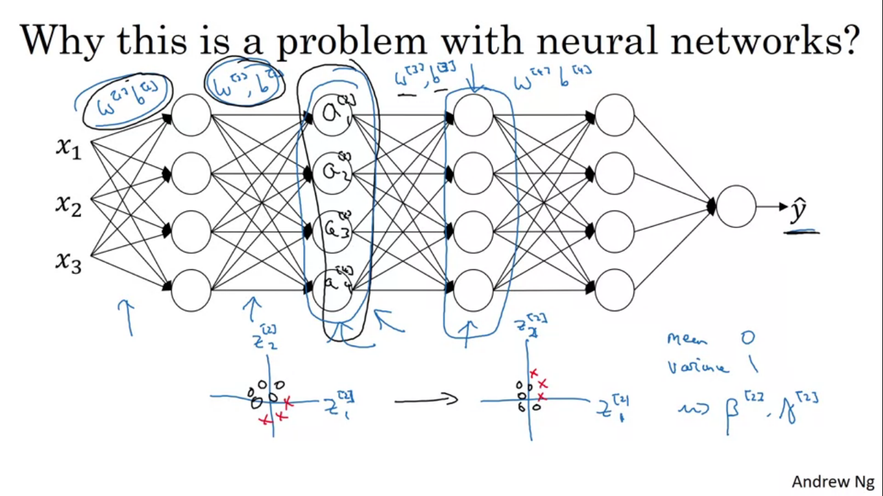

Batch norm reduces the amount that the distribution of these hidden unit values shifts around. No matter how the values of Z[2] will change the mean and variance will remain the same 0 and 1,not necessarily 0 and 1 but what values governed by beta[2] and gamma[2].

It limits the amount to which updating the parameters in the earlier layers can affect the distribution of values that the third layer has seen and therefore has to learn on. Batch norm causes the values to be stable so that the later layers of NN has more firm ground to stand on. It reduces the coupling between what the earlier layer parameters have to do and what the later layer parameters have to do and allows each layer to learn more independently.

**Batch norm as Regularization**

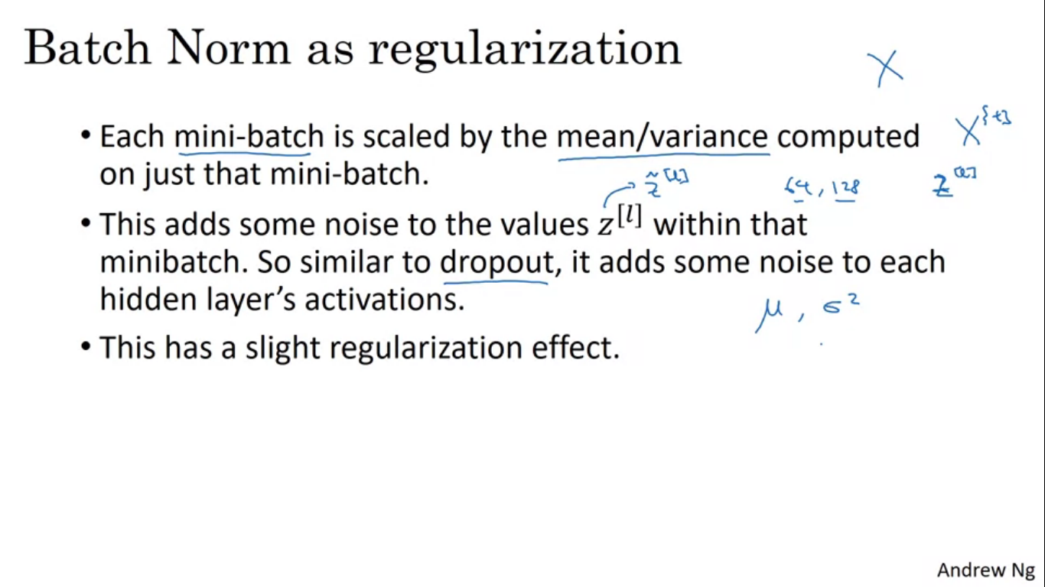

Batch norm has noise because of scaling by standard deviation and additive noise because it is subtracting the mean. By using a larger mini batch size we are reducing the noise and also this regularization effect.

Batch norm handles data one mini batch at a time. But at test time we might need to process the examples one at a time.

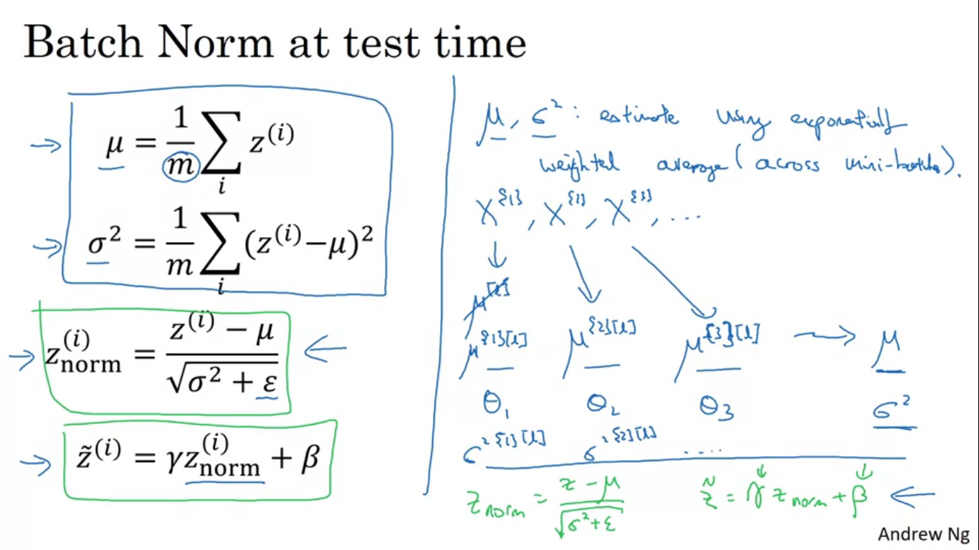

M is used to denote the number of examples in the whole mini batch. Mean and standard deviation are computed on the entire mini batch. So at test time what is required is to come up with a separate estimate of mean and SD using exponentially weighted average across the mini batches. We find the exponentially weighted average to compute the latest average values of this mean vector you have seen, which becomes the mean and similarly for SD.

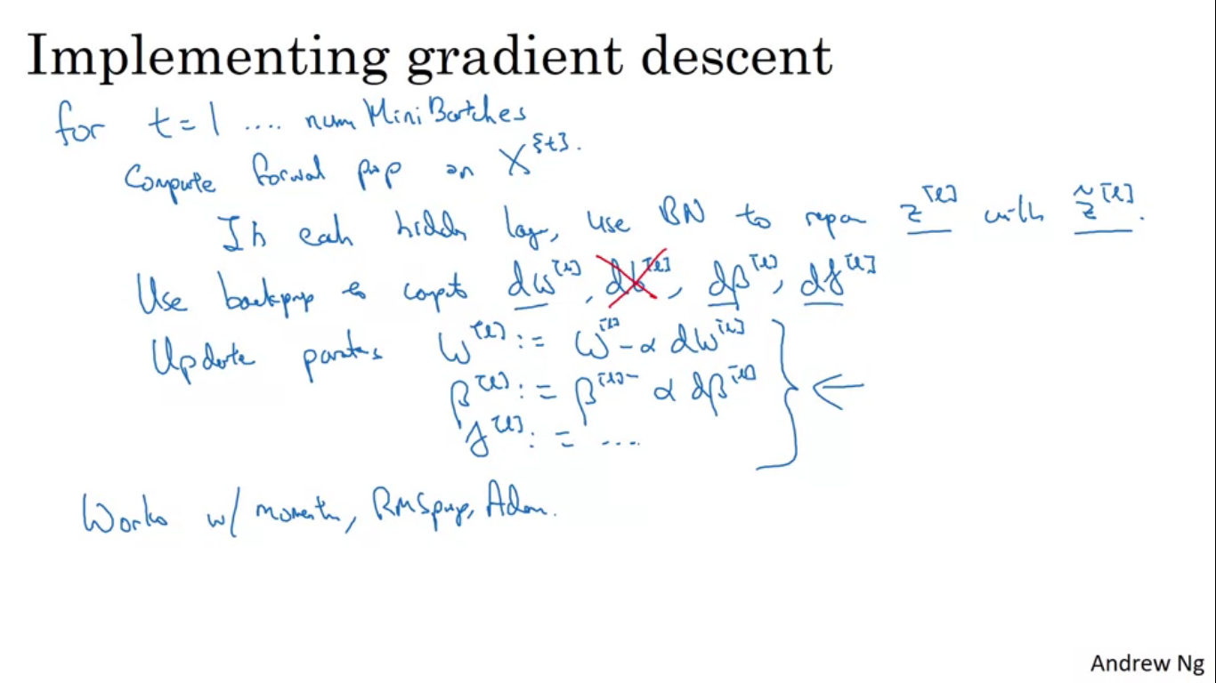

**Softmax Regression for multiclass classification**

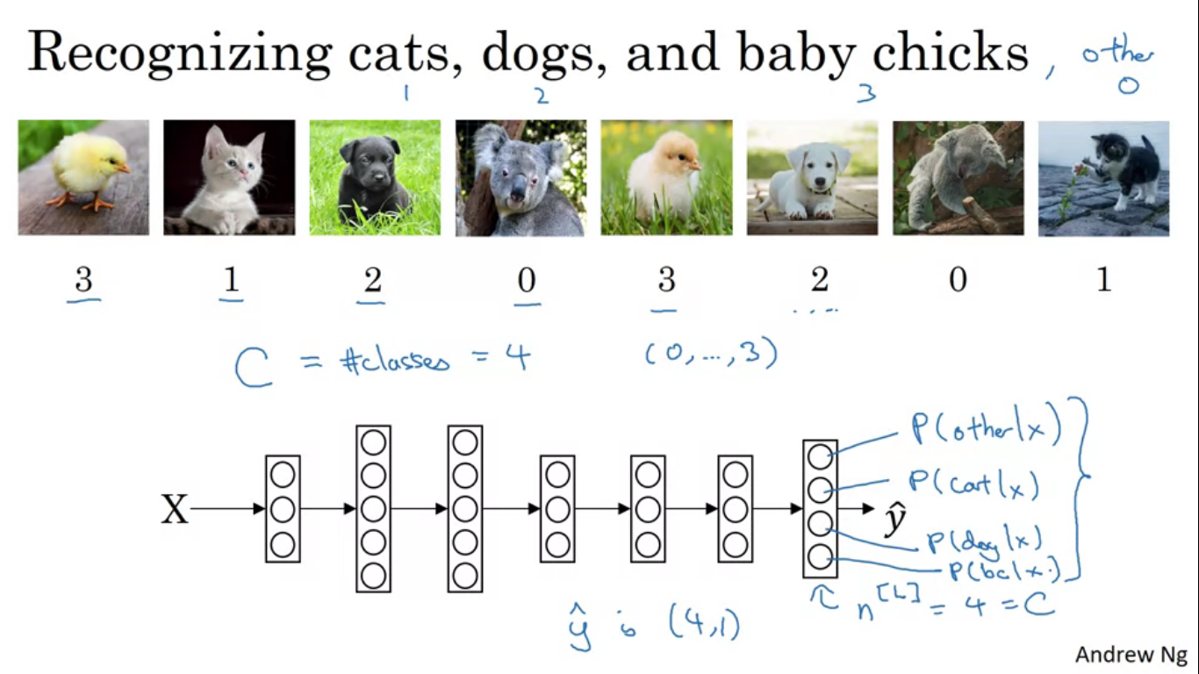

There is a generalization of logistic regression called as softmax regression that lets you classify one of multiple classes.

Notation

C = number of classes you are trying to categorise. Here = 4

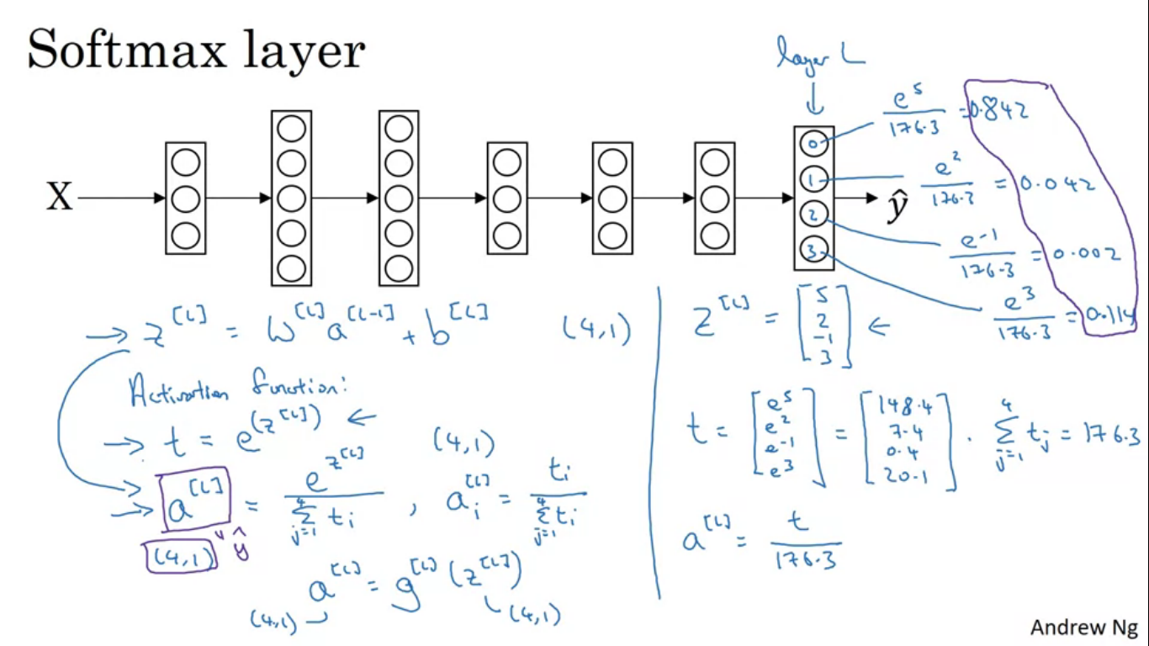

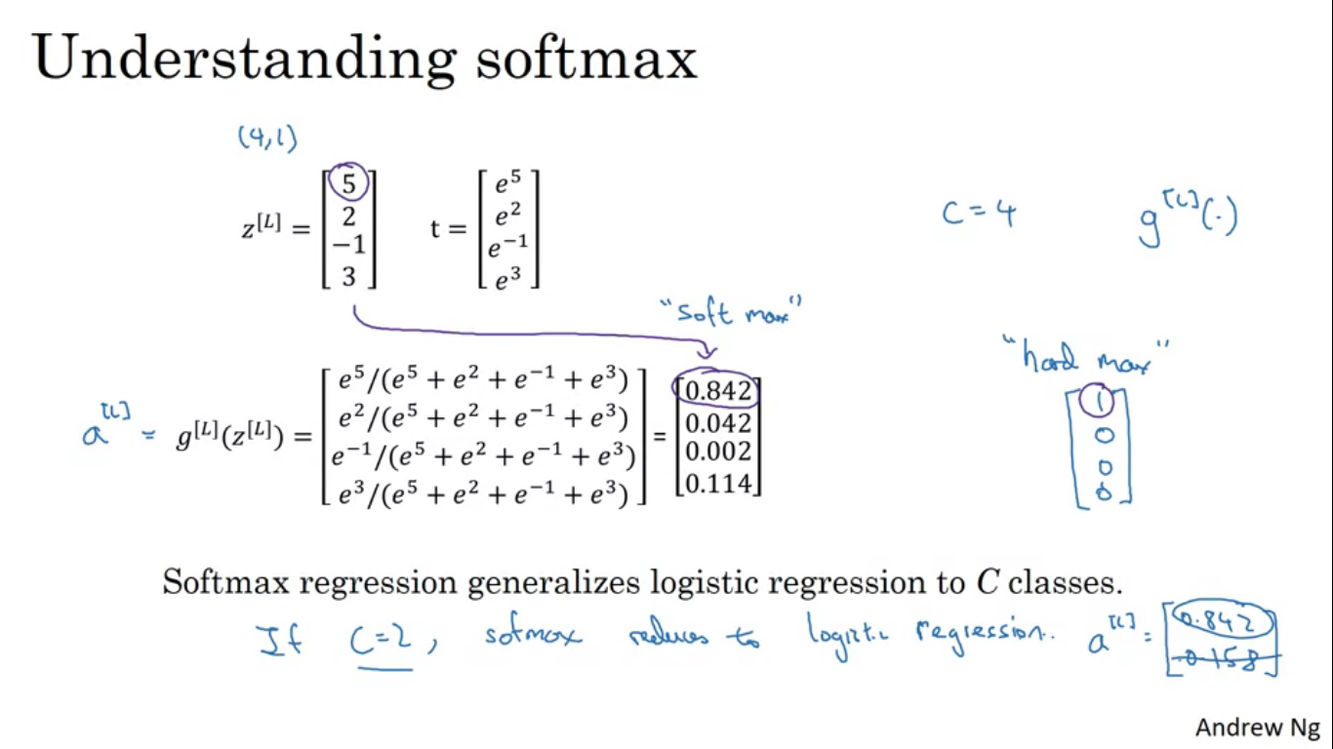

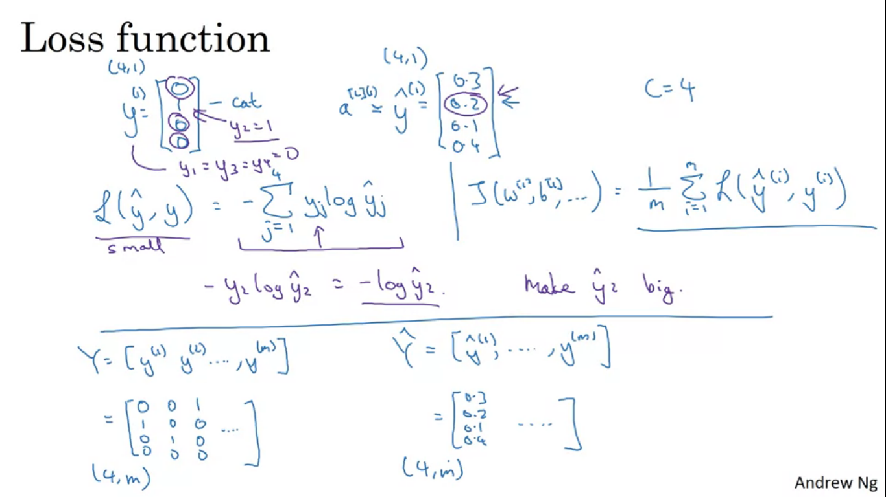

The NN will have C output units. yhat is going to be a CX1 dimensional vector giving us the four probabilities. The all the C probabilities in the output yhat should sum to 1.

The standard model to do this uses the softmax layer and an output layer to generate these outputs. The softmax function takes in input a 4X1 vector and outputs a 4X1 vector.

Softmax classifier with no hidden units

The decision boundary between any two classes will be more linear, but to use linear function in order to separate.

**Training of softmax classifier**

What the loss function does is that it looks at gound true class in your training set and it tries to make the corresponding probability of that class as high as possible.

Also look at the dimensions of the various matrixes in the images.

**Gradient descent with softmax**

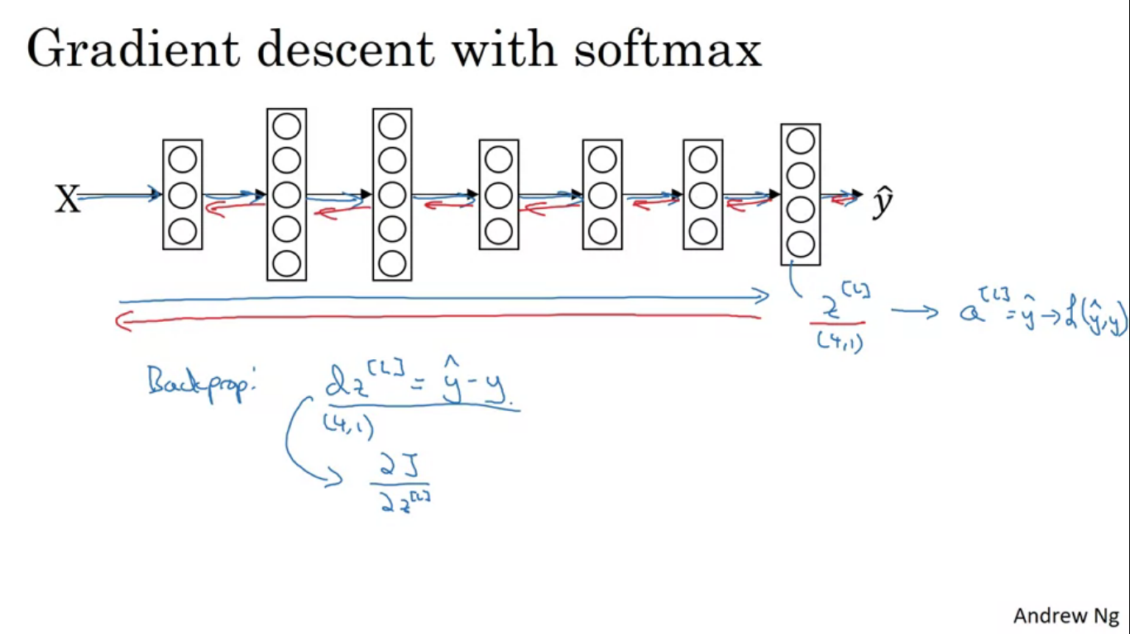

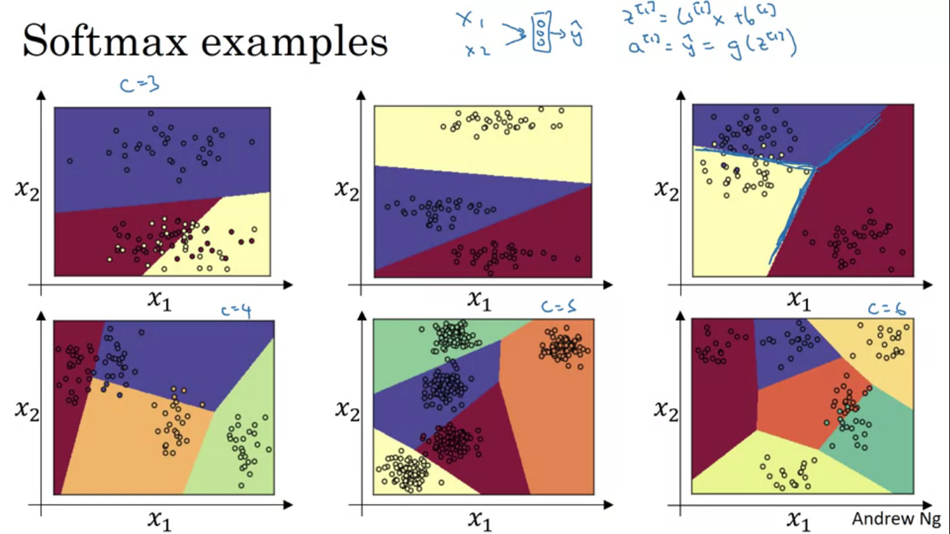

**Deep Learning Frameworks**

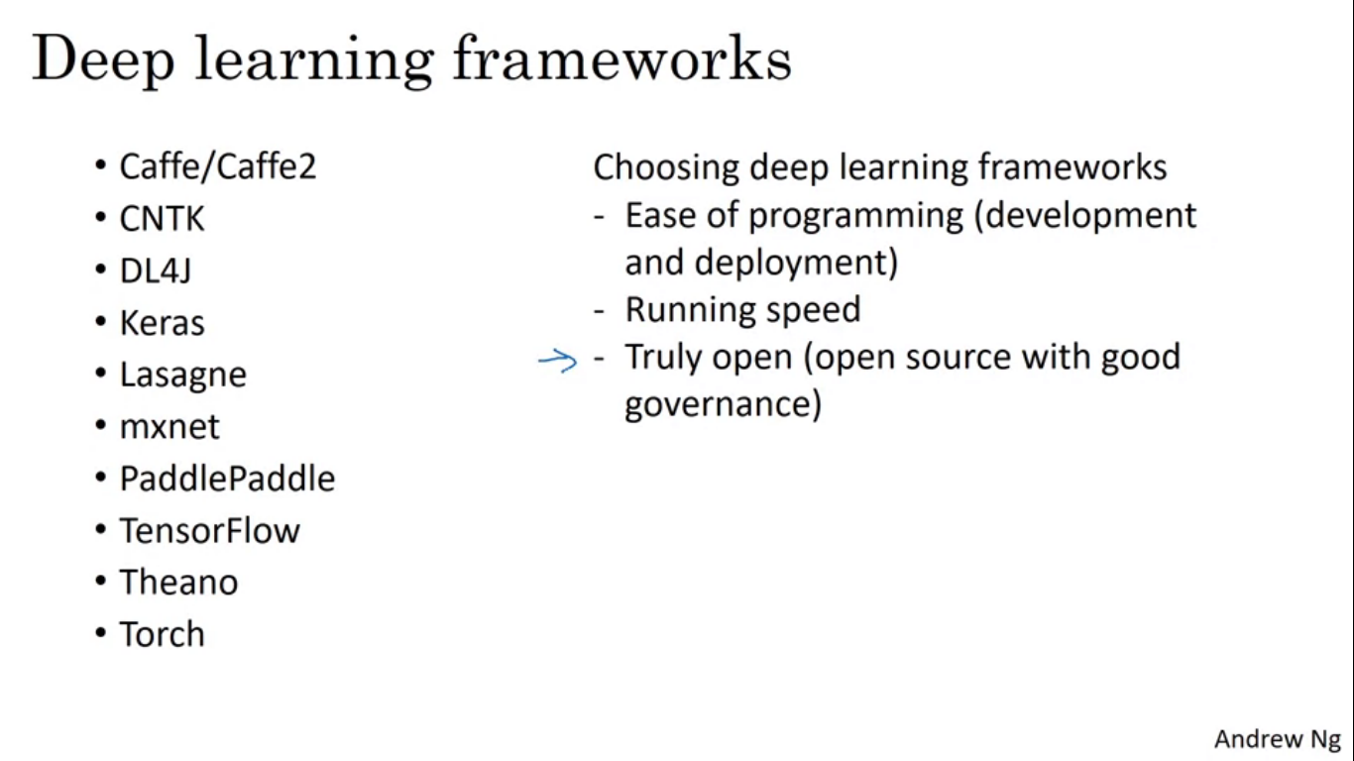

Initially we developed the models from scratch using python and numpy, but in cases of very big models this approach is not always practical. There are several good deep learning software frameworks that can help us implement these models.

Each of the frameworks have a dedicated user and developer community and each of these frameworks are a credible choice for some subset of applications.

For a framework to be truly open, it not needs to be just open source but it needs good governance as well. Some companies initially provide open source but as the software gets popular they close off what was open source or moving functionality into their own proprietary cloud services.

Tensorflow

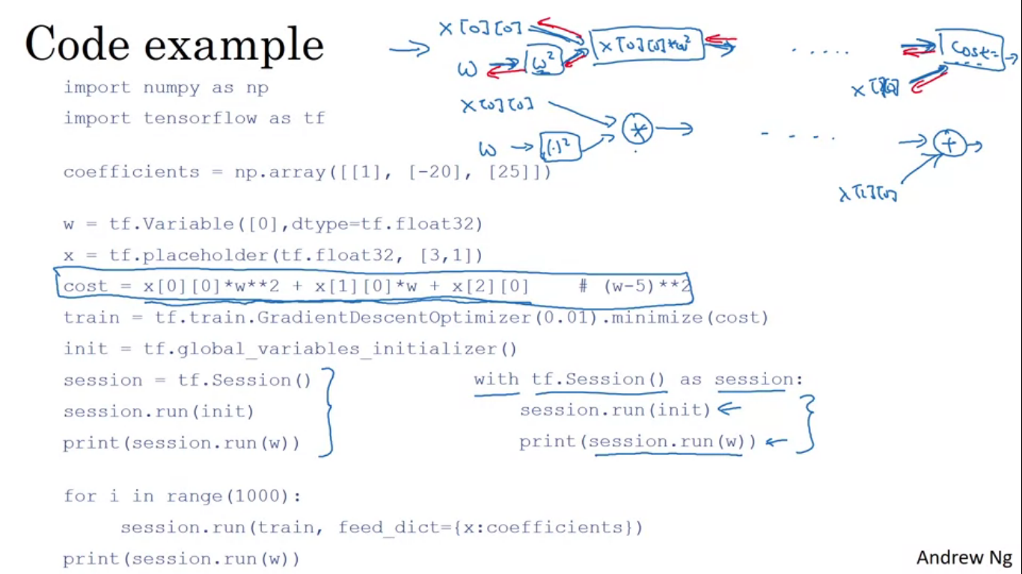

You have some cost function J that you want to minimize,

J(w) = W^2 – 10W + 25

Tensorflow Programming

The heart of tensorflow program is something to compute as cost and then tensorflow automatically figures out the derivatives and how to minimize that costs.

The equation is allowing tensorflow to construct a computation graph. It takes x[0][0]and then takes w , squares it and then x[0][0] gets multiplied with w squared.

Writing and running programs in TensorFlow has the following steps:

1. Create Tensors (variables) that are not yet executed/evaluated.

2. Write operations between those Tensors.

3. Initialize your Tensors.

4. Create a Session.

5. Run the Session. This will run the operations you'd written above.

Therefore, when we created a variable for the loss, we simply defined the loss as a function of other quantities, but did not evaluate its value. To evaluate it, we had to run `init=tf.global_variables_initializer()`. That initialized the loss variable, and in the last line we were finally able to evaluate the value of `loss` and print its value.